Assignment 1: Create a document with screenshots Working with Git Repo

Create a Repository : Wipro Training

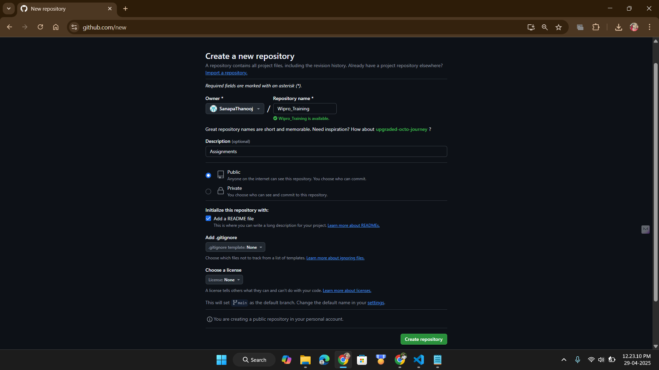

Cloned Repository

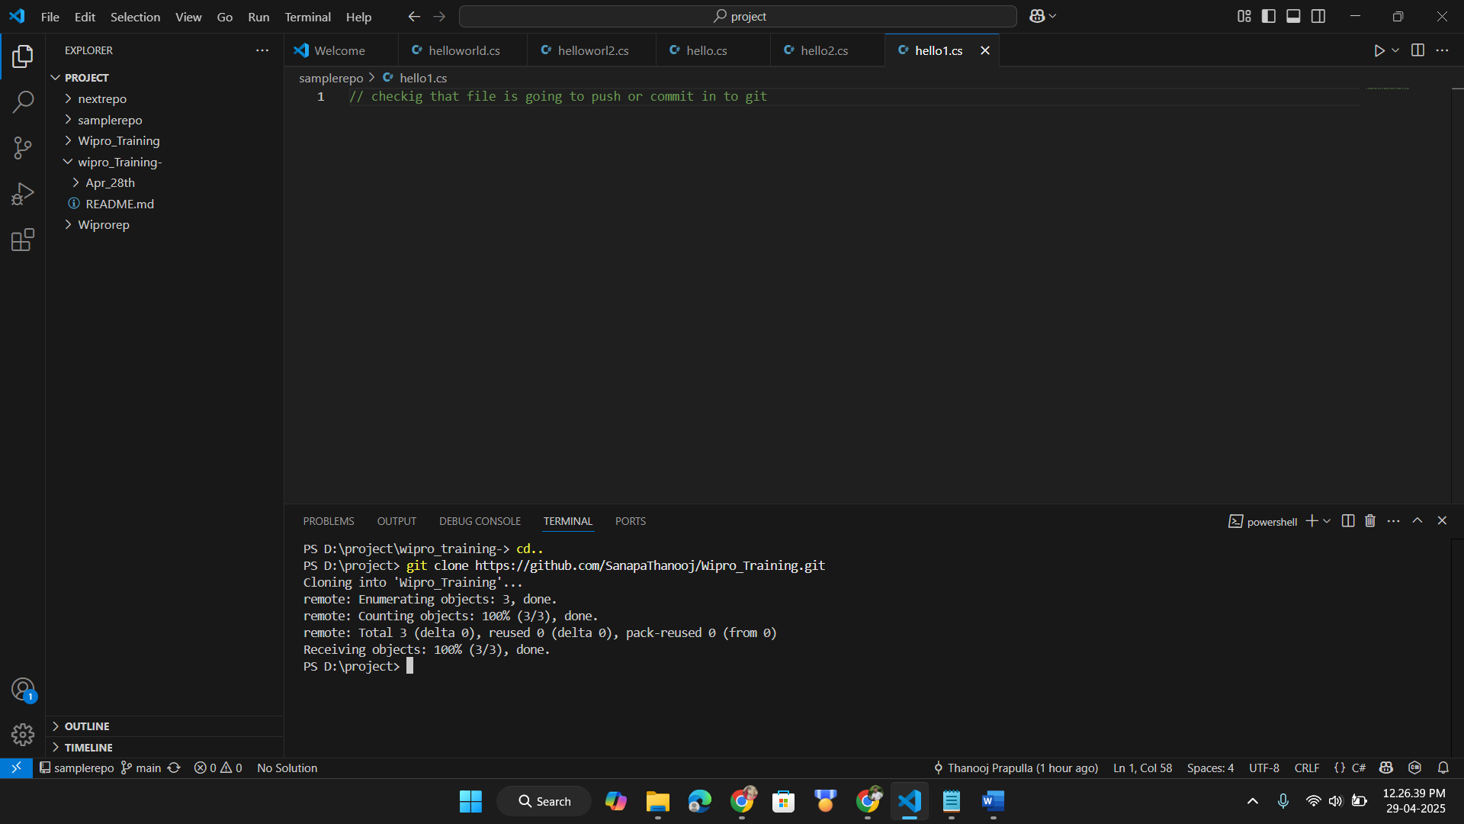

Copying the assignment to git hub

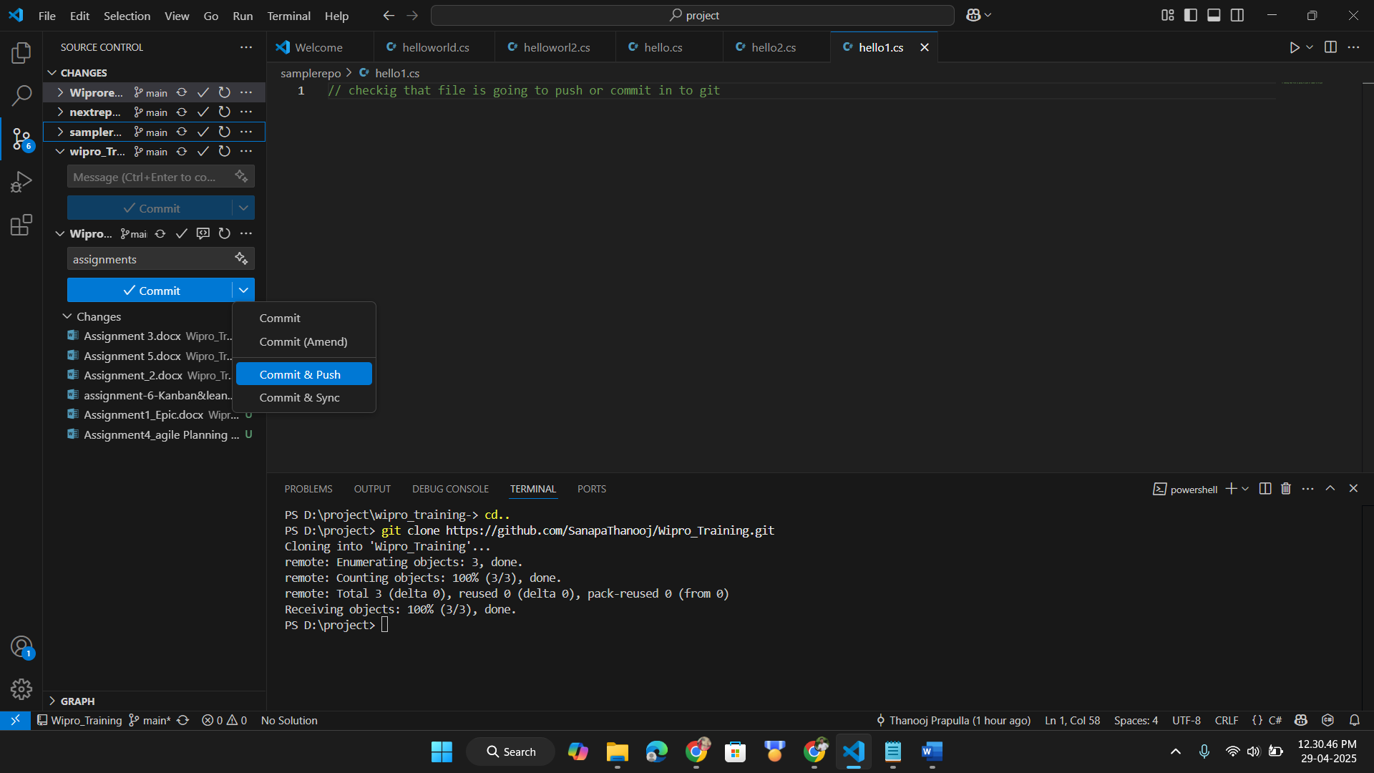

Successfully pushed

